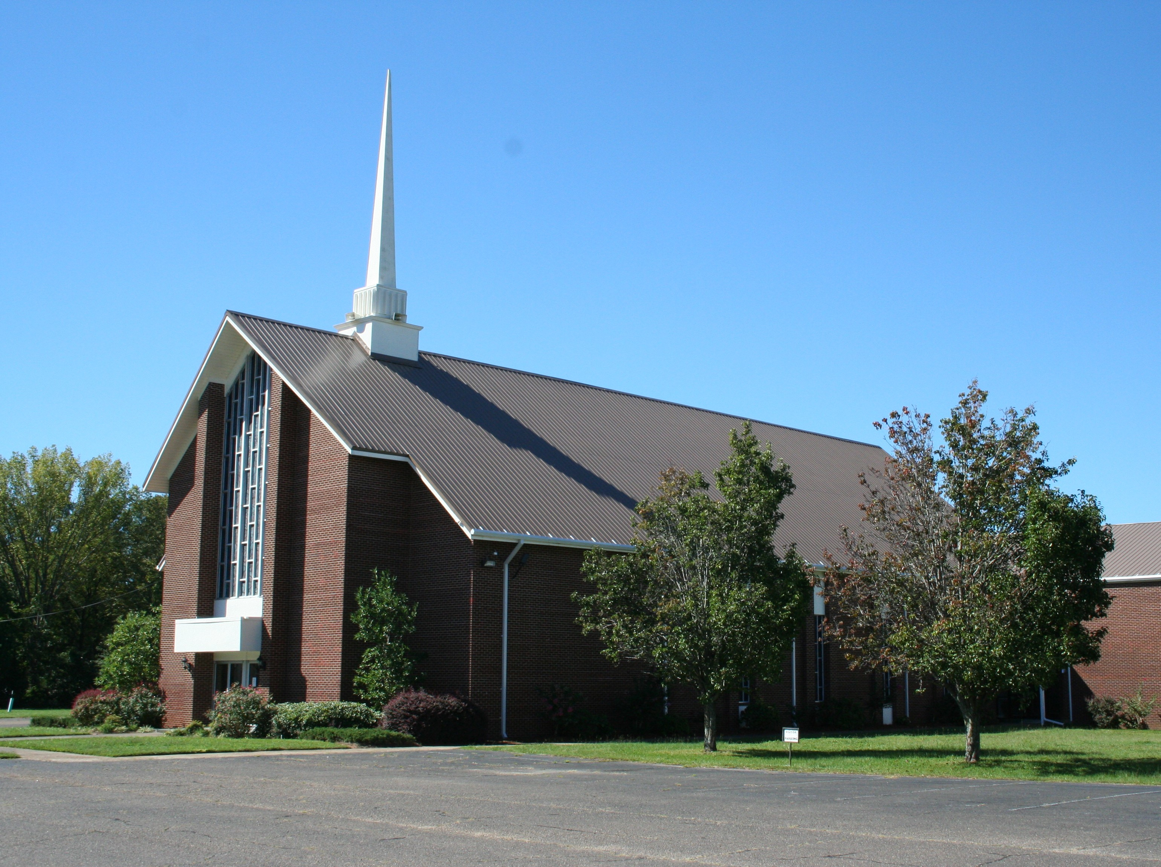
Artist and Album Title
Artist and Album Title
Artist and Album Title
Artist and Album Title

First Baptist Church
of Pearl
November 2, 2014
Morning Service
Evening Service
First Baptist Church
of Pearl
November 2, 2014
Morning Service
Evening Service

DVD
Pastor Scott Crawford
Recorded and designed
by James F Thompson Jr

Pastor Scott Crawford

DVD
Recorded and designed
by James F Thompson Jr

