**The Jewish Bible**

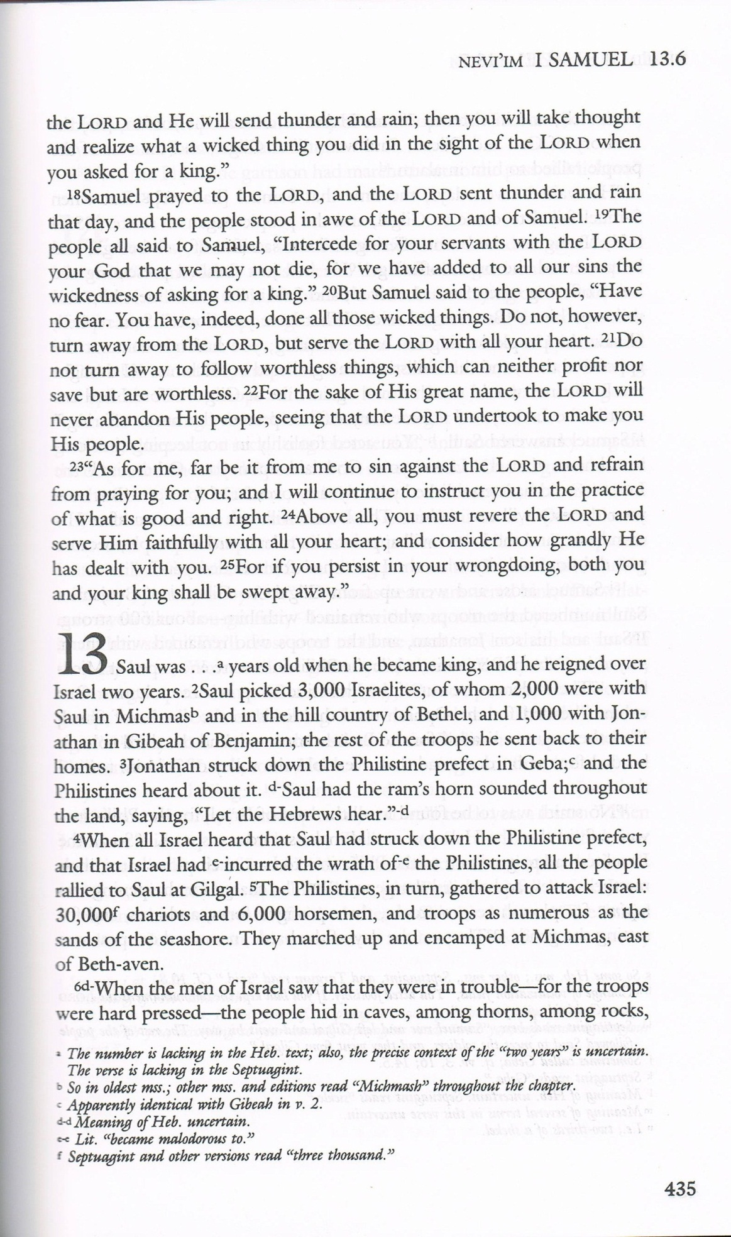

The Orthodox Bible (St. Athanasius Academy Septuagint)

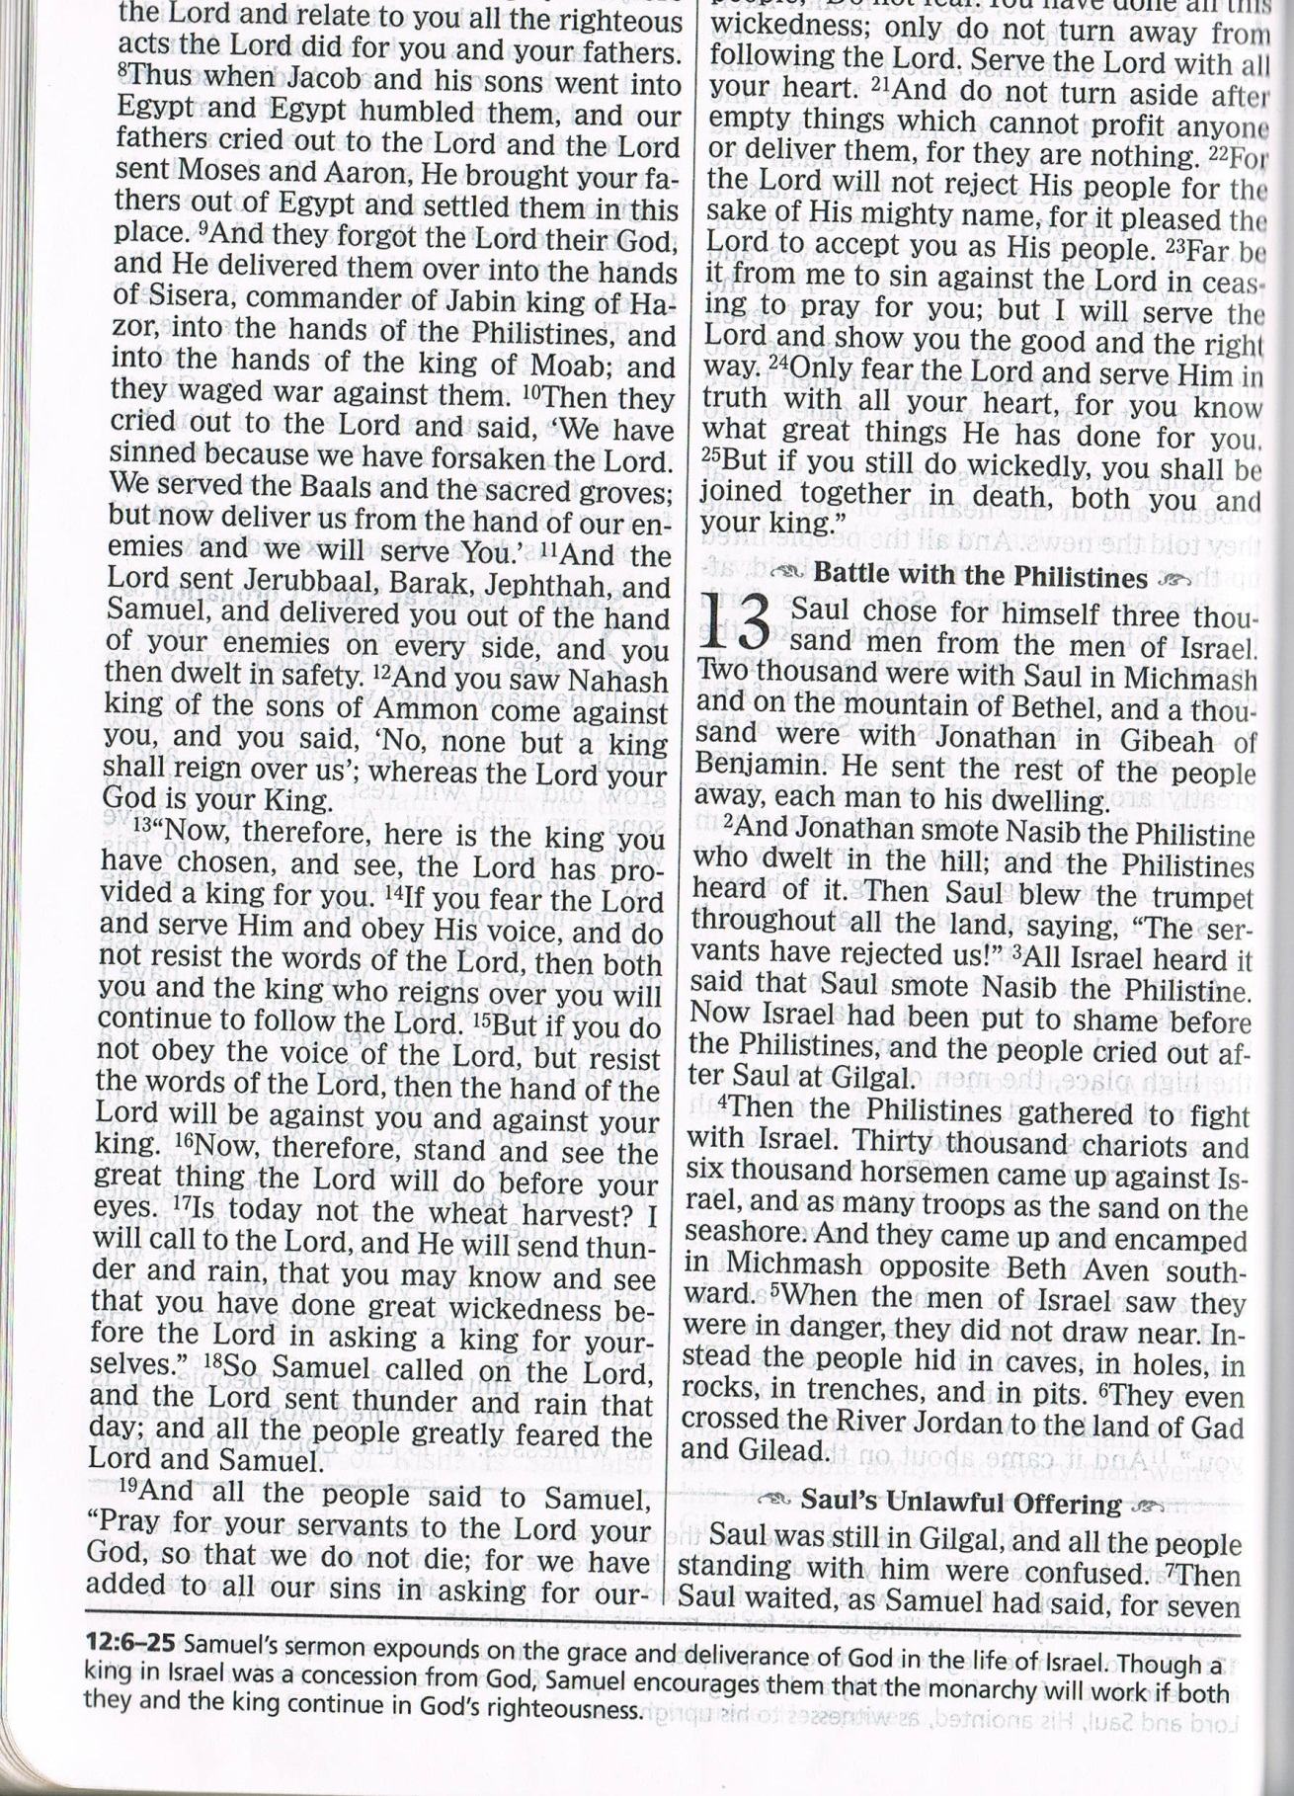

The Interlinear Bible (Masoretic Text)

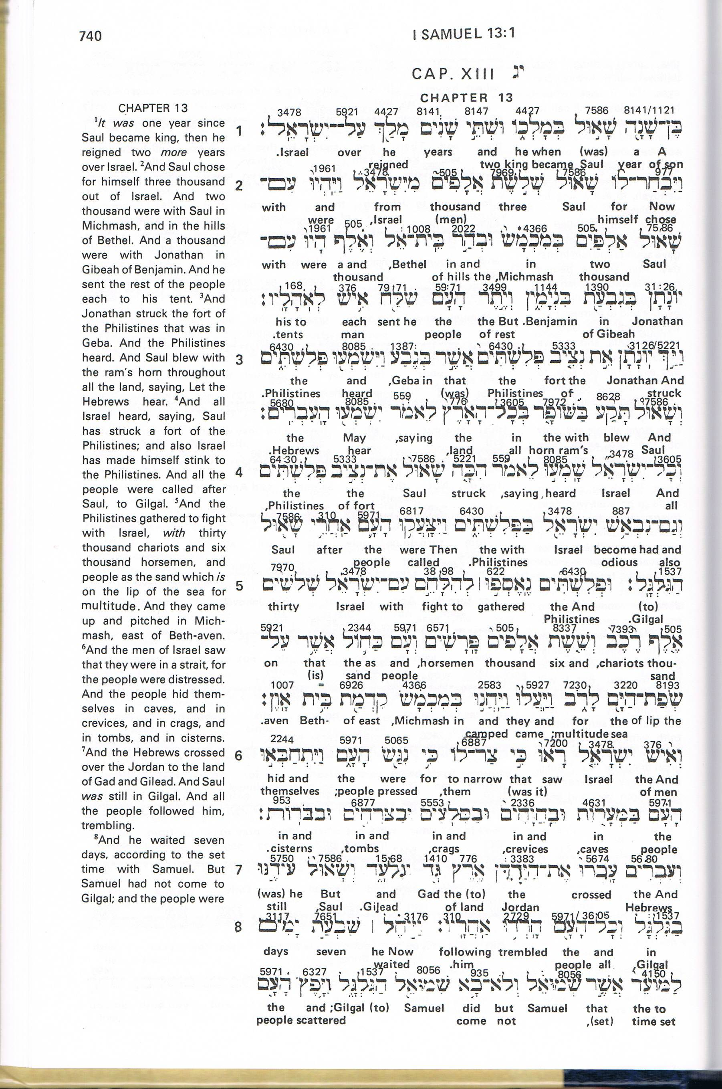

The New American Standard Bible

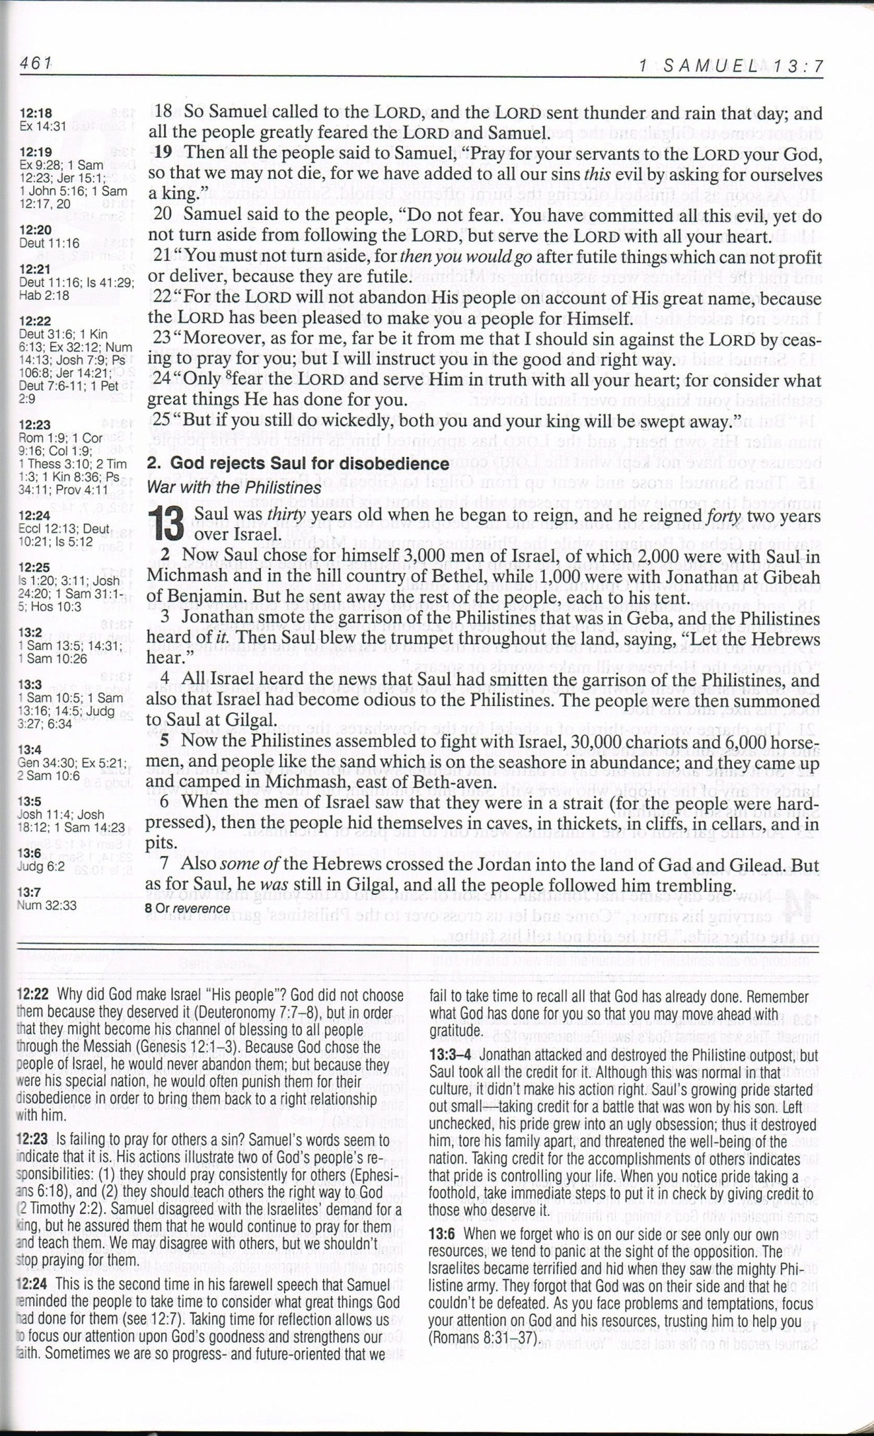

**1** Saul reigned one year; and when he had reigned two years over Israel,

1 Sam 13:1 (KJV)

…………………..

**1** Saul was 30 years (Some LXX mss; MT reads *was one year*) old when he became king, and he reigned 42 years (Text emended; MT reads *two years*) over Israel. (Some LXX mss omit v.1)

1 Samuel 13:1 (HCSB)

…………………………………..

**1** Saul was {thirty} years old when he became king, and he was king of Israel {forty-two} years. (The text of 1 Samuel 13:1 is problematic in all traditions. Some late Greek manuscripts state Saul was 30 years old when he became king. The ancient Jewish historian Josephus and Acts 13:21 state that Saul ruled for 40 years.)

1 Sam 13:1 (GW)

……………………….

**1 Samuel 13:1**

**Saul** **reigned** **one** **year** - A great deal of learned labor has been employed and lost on this verse, to reconcile it with propriety and common sense. I shall not recount the meanings put on it. I think this clause belongs to the preceding chapter, either as a part of the whole, or a chronological note added afterwards; as if the writer had said, These things (related in 1 Samuel 12:1-25) took place in the first year of Saul’s reign: and then he proceeds in the next place to tell us what took place in the second year, the two most remarkable years of Saul’s reign. In the first he is appointed, anointed, and twice confirmed, viz., at Mizpeh and at Gilgal; in the second, Israel is brought into the lowest state of degradation by the Philistines, Saul acts unconstitutionally, and is rejected from being king. These things were worthy of an especial chronological note.

**And** **when** **he** **had** **reigned** - This should begin the chapter, and be read thus: “And when Saul had reigned two years over Israel, he chose him three thousand,” etc. The Septuagint has left the clause out of the text entirely, and begins the chapter thus: “And Saul chose to himself three thousand men out of the men of Israel.”

Adam Clarke’s Commentary

…………………………….

**Chapter 13**

**13:1 2** And Saul chooses for himself three thousand men of the men of Israel: and there were with Saul two thousand who were in Machmas, and in mount Baethel, and a thousand were with Jonathan in Gabaa of Benjamin: and he sent the rest of the people every man to his tent.

LXX (Septuagint)