How Literal?
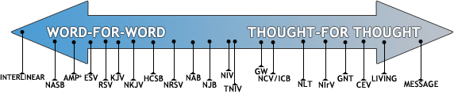

At one end of the spectrum is the word-for-word translation (also referred to as a formal equivalent or literal translation). This approach seeks to represent the original Greek and Hebrew in a more word-for-word manner and preserve—as far as possible—original word order, grammar, and syntax. Many prefer this method because each Greek or Hebrew word is generally represented by the same English word in all occurrences. Some of the more literal translations include: the King James Version (KJV), the New King James Version (NKJV), the English Standard Version (ESV), and the New American Standard Bible (NASB). The most literal translation is the interlinear which contains the text in its original language with the English equivalent underneath the text.
On the other end of the spectrum we find the thought-for-thought translation (also referred to as a paraphrase or functional equivalent). This approach is more concerned with putting meaning of the passage in a colloquial language familiar to the reader. This type of translation seeks to render the ideas of the original text as accurately as possible in the target language (like English). Some examples in this category are: The Philips New Testament in Modern English, The Living Bible, and The Message (by Eugene Peterson). Many find this translation more readable, especially for new readers.
The middle of the spectrum is occupied by the dynamic equivalent, or mediating translation. These translations seek to strike a balance between the two translation approaches. They are sometimes more literal, sometimes more colloquial or conversational depending on the subject and text. Some examples in this category are the New International Version (NIV), Holman Christian Standard Bible (HCSB), and the New American Bible (NAB).
Many find it helpful to consult more than one translation—or to use different translations in different settings. While a more literal translation is suitable for study, a more less literal translation is desired for devotional or casual reading. A Parallel Bible contains two or more translations for easy comparison.

Source: http://www.christianbook.com/Christian/Books/cms_content?page=73521&sp=104481

