Psalm 46:10
'Be Still and Know that I AM GOD'
Please don't break this even if you only send it to one person. Look at the date when this was started.
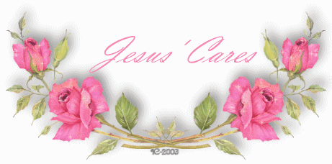
NOTICE AT THE END, THE DATE THIS CANDLE WAS STARTED.
GONNA GIVE YOU GOOSE BUMPS
I am not going to be the one who lets it die. I found it believable -
Angels have walked beside me all my life-and they still do.

This is to all of you who mean something to me, I pray for your happiness.
The Candle Of Love, Hope & Friendship
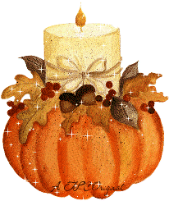
15th of September, 1998.
Someone who loves you has helped keep it alive by sending it to you.
Don't let The Candle of Love, Hope and Friendship die! Pass It On
To All Your Friends and Everyone You Love! May God richly bless you as you keep this candle burning. I received this today for the 1st
time and I hope it comes back someday again.
Please keep this candle alive.
Don't walk in front of me, I may not follow.
Don't walk behind me, I may not lead.
Just walk beside me and be my friend

