Working Replica of Noah's Ark

Amazing

This is truly amazing! Cannot even imagine the work, time, and money that went into this venture. It's also amazing to see how large this is - and that the fact it is to scale of biblical times. Enjoy.

Working Replica of Noah's Ark
Opens In SCHAGEN, Netherlands
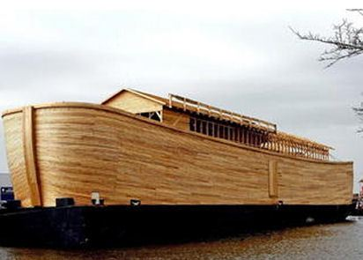
The massive central door in the side of Noah's Ark was thrown open Saturday
for the first crowd of curious Pilgrims and townsfolk to behold the wonder.
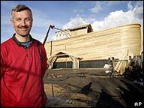

Of course, it's only a replica of the biblical Ark , built by Dutch
Creationist Johan Huibers as a testament to his faith in the literal truth of the Bible.
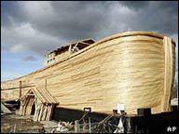
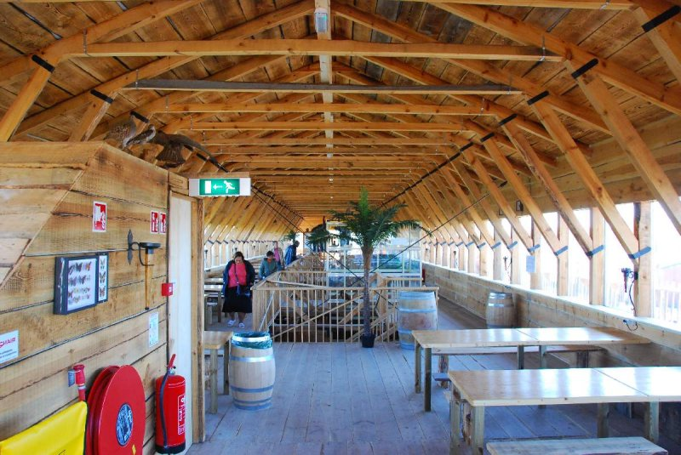
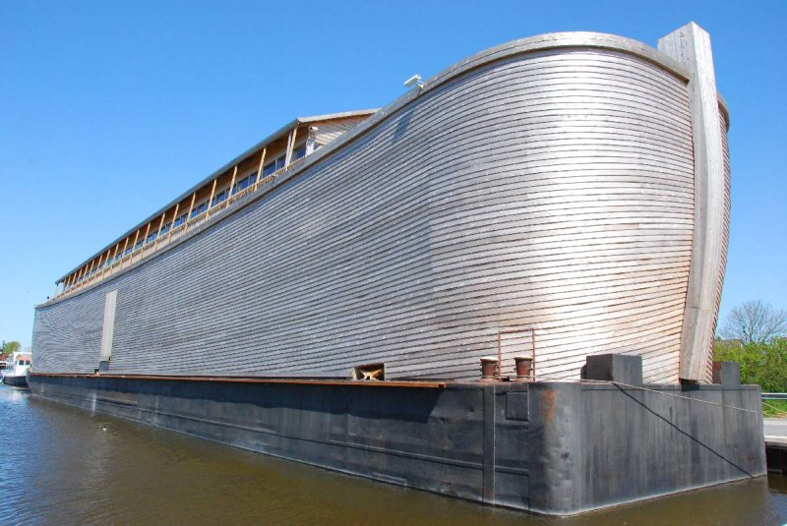
The ark is 150 cubits long, 30 cubits high and 20 cubits wide. That's two-thirds the length of a football field and as high as a three-story house.
Life-size models of giraffes, elephants, lions, crocodiles, zebras,
bison and other animals greet visitors as they arrive in the main hold.
A contractor by trade, Huibers built the ark of cedar and pine -
Biblical Scholars debate exactly what the wood used by Noah would have been.
Huibers did the work mostly with his own hands, using modern tools
and with occasional help from his son Roy. Construction began in
May 2005.
On the uncovered top deck - not quite ready in time for the opening
- will come a petting zoo, with baby lambs and chickens, and goats,
and one camel.
Visitors on the first day were stunned.
'It's past comprehension, ' said Mary Louise Starosciak, who
happened to be bicycling by with her husband while on vacation
when they saw The ark looming over the local landscape.
'I knew the story of Noah, but I had no idea the boat would have been so big.'
There is enough space near the keel for a 50-seat film
theater where kids can watch a video that tells the story of Noah
and his ark.
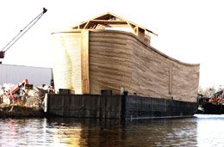
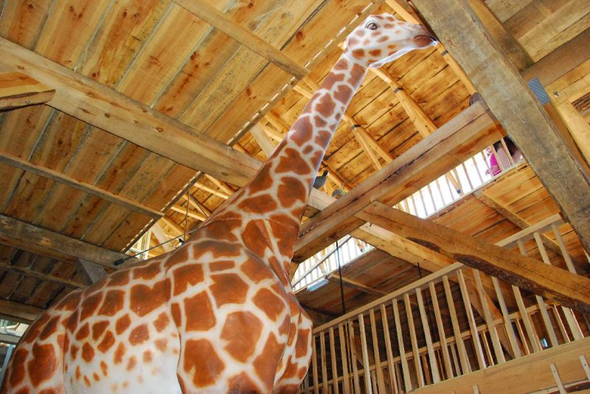
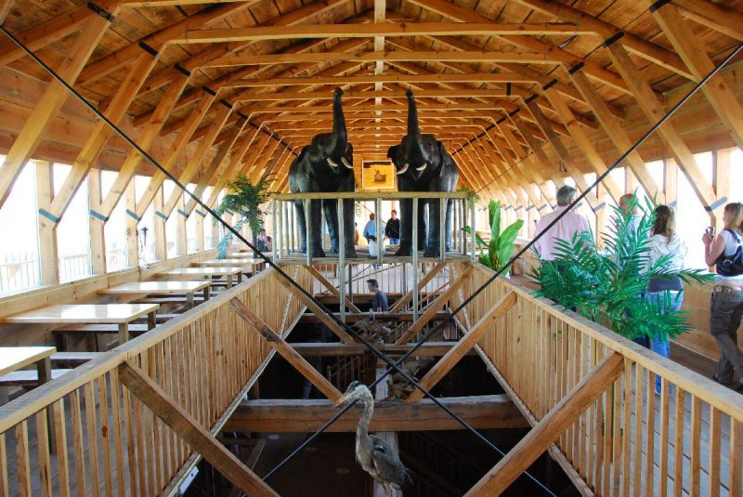
Huibers said he hopes the project will renew interest in Christianity in
the Netherlands , where church going has fallen dramatically in the past 50 years.
''If You Need Help, Ask God. If You Don't, Thank God''...
'Surely goodness and mercy shall follow me all the days of my life;
and I will dwell in the house of the Lord forever.' Psalm 23:6

When there is nothing left but God, that is when you
find out that God is all you need. Live today to the
fullest because tomorrow is not promised.

Now that I am old and
gray...give me the time to tell
this new generation
(and their children too)
about all your mighty miracles.
Psalm 71:18
