The Collective Works
Of
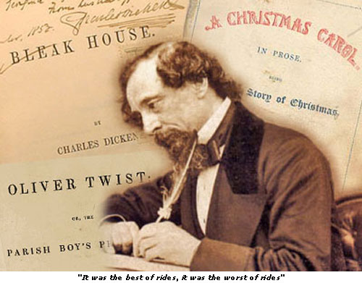

Charles Dickens
Life: 1812-1870

90 eBooks:
American Notes, [en] 1843
Aventures de Monsieur Pickwick, Vol. I, [fr] 1893
Barnabé Rudge, Tome I, [fr] 1841
Barnabé Rudge, Tome II, [fr] 1841
Barnaby Rudge
A Tale of the Riots of 'Eighty, [en] 1841
The Battle of Life, [en] 1846
Bleak House, [en] 1853
A Budget of Christmas Tales by Charles Dickens and Others, [en] 1895
Cantique de Noël, [fr]
Captain Boldheart & the Latin-Grammar Master
A Holiday Romance from the Pen of Lieut-Col. Robin Redforth, aged 9, [en] 1867
A Child's History of England, [en] 1867
The Chimes, [en] 1844
A Christmas Carol, [en] 1843
A Christmas Carol, [en] 1905
Contributions to All The Year Round, [en]
The Cricket on the Hearth, [en] 1845
The Cricket on the Hearth
A Fairy Tale of Home, [en] 1905
David Copperfield, [en] 1849
David Copperfield - Tome I, [fr] 1850
David Copperfield - Tome II, [fr] 1850
David Copperfield I
David Copperfield nuoremman elämäkertomus ja kokemukset, [fi] 1849
David Copperfield II
David Copperfield nuoremman elämäkerta ja kokemukset, [fi]
Der Weihnachtsabend
Eine Geistergeschichte, [de]
Doctor Marigold, [en] 1868
Dombey and Son, [en] 1848
Een Kerstlied in Proza, [nl] 1843
George Silverman's Explanation, [en] 1870
Going into Society, [en] 1858
Great Expectations, [en] 1861
Hard Times, [en] 1854
The Haunted Man and the Ghost's Bargain
A Fancy for Christmas-Time, [en] 1848
Holiday Romance, [en]
The Holly-Tree Inn
Three Branches, [en] 1855
A House to Let, [en]
A House to Let, et al, [en] 1858
Hunted Down, [en] 1870
Ilman menestyksettä
Joulukertomus, [fi] 1867
Joulun-aatto, [fi] 1878
La Batalo de l' Vivo, [eo] 1891
The Lamplighter, [en]
Lazy Tour of Two Idle Apprentices, [en] 1905
Le grillon du foyer, [fr]
Le magasin d'antiquités, Tome I, [fr] 1840
rLe magasin d'antiquités, Tome II, [fr] 1840
Les conteurs à la ronde, [fr] 1886
Les grandes espérances, [fr] 1861
The Letters of Charles Dickens
Vol. 1, 1833-1856, [en] 1880
The Letters of Charles Dickens
Vol. 2, 1857-1870, [en] 1880
The Letters of Charles Dickens
Vol. 3, 1836-1870, [en] 1880
The Life and Adventures of Nicholas Nickleby
containing a Faithful Account of the Fortunes, Misfortunes, Uprisings, Downfallings and Complete Career of the Nickelby Family, [en] 1839
Little Dorrit, [en] 1855
The Loving Ballad of Lord Bateman, [en]
The Magic Fishbone
A Holiday Romance from the Pen of Miss Alice Rainbird, Aged 7, [en] 1867
Martin Chuzzlewit, [en] 1844
Master Humphrey's Clock, [en] 1840
A Message From the Sea, [en] 1894
Miscellaneous Papers, [en]
Mrs Lirriper's Legacy, [en] 1864
Mrs Lirriper's Lodgings, [en] 1863
Mudfog and Other Sketches, [en] 1903
Mugby Junction, [en] 1866
Mugbyn risteys, [fi] 1869
The Mystery of Edwin Drood, [en] 1870
No Thoroughfare, [en] 1867
The Old Curiosity Shop, [en] 1841
Oliver Twist
or, The Parish Boys Progress, [en] 1839
Oliver Twist
[French Translation], [fr] 1839
Our Mutual Friend, [en] 1865
Perils of Certain English Prisoners, [en]
The Perils of Certain English Prisoners, [en] 1894
The Pickwick Papers, [en] 1836
Pictures From Italy, [en] 1846
Reprinted Pieces, [en]
The Seven Poor Travellers, [en]
Sisar Rosa, [fi] 1879
Sketches by Boz, [en] 1836
Sketches of Young Couples, [en]
Sketches of Young Gentlemen, [en]
Some Christmas Stories, [en] 1853
Somebody's Luggage, [en]
Speeches: Literary and Social, [en]
Sunday Under Three Heads, [en]
A Tale of Two Cities, [en] 1859
Tales from Dickens, [en] 1905
Three Ghost Stories, [en]
To Be Read At Dusk, [en]
Tom Tiddler's Ground, [en] 1878
The Uncommercial Traveller, [en] 1869
The Wreck of the Golden Mary, [en]

