1. Locate the ePub ebook title you want to read on this disc.

2. Launch iTunes and select Add to Library… from the File menu.
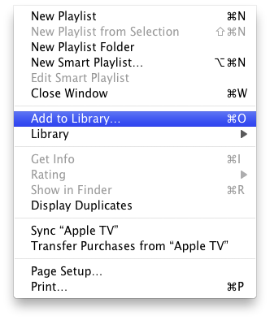
3. Select the eBook you want from this disc and click the Choose button.
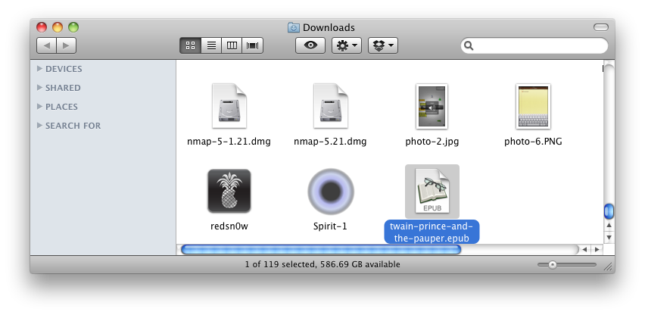
4. Back in iTunes, select Books from the list of libraries on the left. Your book is now listed as part of your library, you’re halfway there.
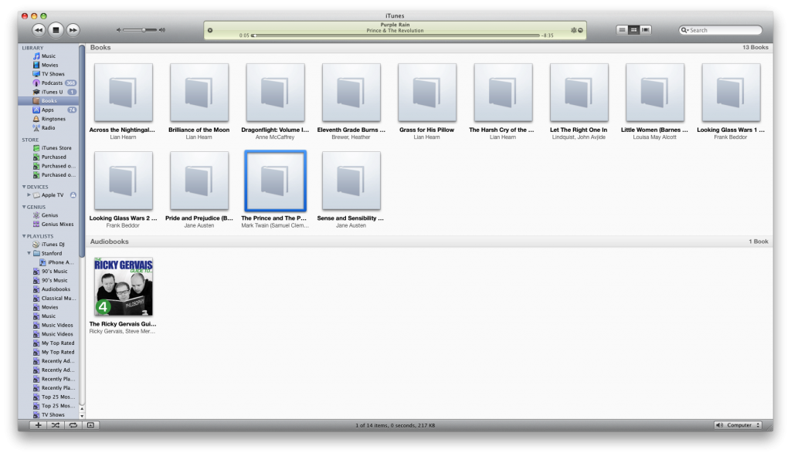
5. Now, connect your iPad, iPod Touch, or iPhone to the computer and select it from the list of devices on the left.
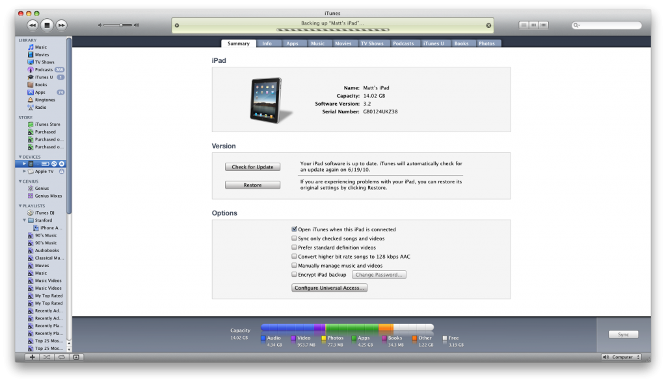
6. Click to select the Books tab.
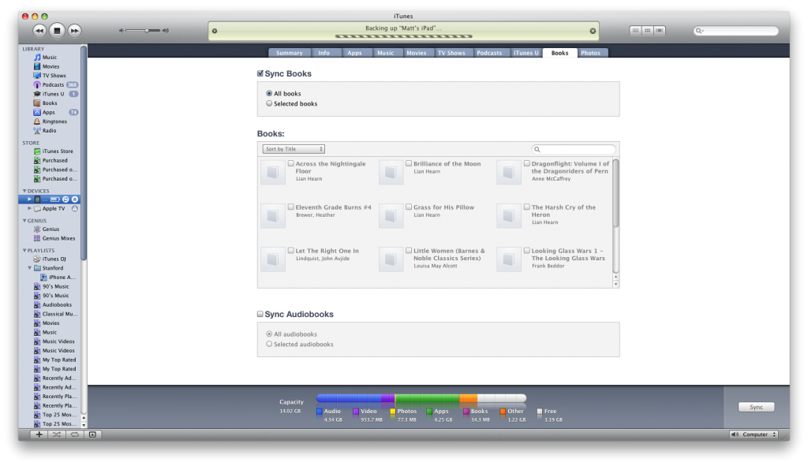
7. Check the Sync Books checkbox if it isn’t already enabled. If All books is selected then all your Books will be transferred to your device. If Selected books is selected then you will need to look below for the newly added Book and check the checkbox next to its title. Now click the Apply or Sync button at the bottom right of the window.
You may receive a warning that this will erase all the books on your iPad if this is your first iBooks sync. Click the Sync Books button.
8. Once the sync has completed you can open iBooks on your iPad, iPod Touch, or iPhone to read your newly transferred title.
*Note: If you do not have iBooks on your device you can download it free from the App Store.
