BellSouth Telecommunications

Regional Design Center Standards

PRELIMINARY

GX550

Asynchronous Transfer Mode

(ATM) Switch

Issue A

April 1, 2000

G. De Lara
(404-927-8918)

GX550 ATM Switch

RDC Standards

1. General

1.1 This document addresses engineering, installation, and ordering information for the Lucent GX550 Asynchronous Transfer Mode (ATM) Switch and associated equipment. The GX 550 is a 25 Gbps non-blocking switch that will be used as a Core Switch in the existing ATM network.

1.2 NOTE: THIS IS A PRELIMINARY ISSUE SUBJECT TO MAJOR CHANGES.

1.3 The GX550 consists of a 37” x 23” x 19” (h,d,w) chassis equipped with a mid-plane bus design and 10 front and rear slots. Broadband Input Output (BIO) processor modules plug into the front and Physical Interface (PHY) modules plug into the rear.

1.4 The PHY modules provide standard SC interfaces at OC3c, OC12c, and OC48c rates. These interfaces are extended to the FDF through appropriate cross-connect jumpers and fiber terminating equipment installed by turf vendors through applicable MBOS models.

1.5 Network Management access is provided “in band” through the ATM/FR network. However, an asynchronous 19.2 kbs connection is required for back-up.

1.6 Provide copies of all TEO’s to Project Manager, FPNA, Suite 500, 1950 West Exchange Place, Tucker, Ga 30084, Fax: 770-496-2762 & 770-496-2764, Tel: 770-496-2882. The DCSC is responsible for scheduling equipment turn-up and ordering official service circuits. Information regarding circuit configurations (i.e., direct cabled or remote, UDS shelf or Conklin units) and circuit terminating points CLLI’s must also be provided to the Network Manager.

Figure 1 - Typical Network Architecture

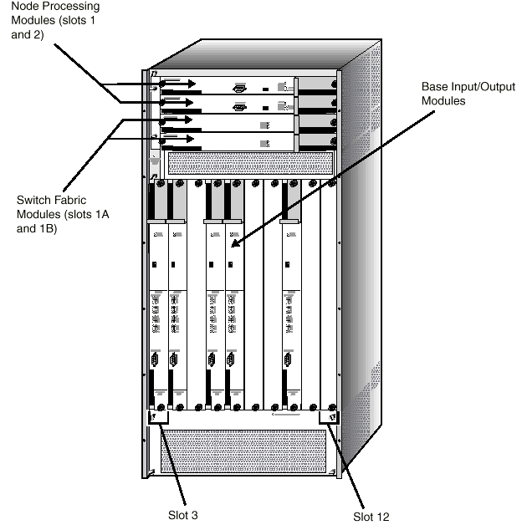
Figure 2 - GX550 Front View
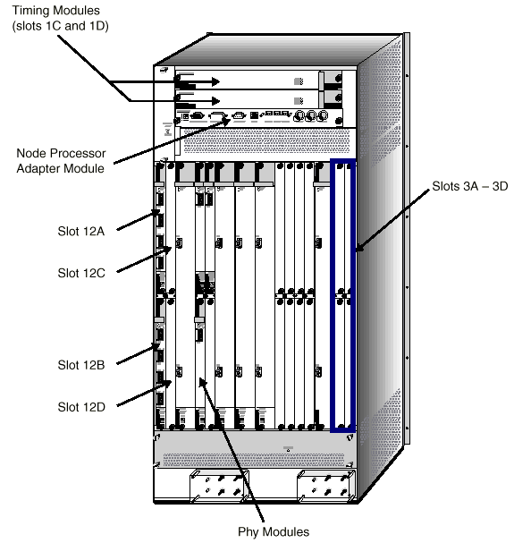
Figure 3 - GX550 Rear View

2. Equipment Configuration

2.1 A fully redundant switch configuration mounted in a cabinet will be deployed. Associated hardware includes a Fiber Terminating Shelf and Fiber Management Panel. Fiber crossconnect jumpers will also be provided for use by CO personnel during customer service turn-up.
Rear View Side View
Figure 4 - Recommended Equipment Layout

3. Installation Notes

3.1 Install switch and associated hardware in cabinet per recommended equipment layout.
Note: Cabinet dimensions are 84”x28”x28”(h,w,d).

3.2 Provide 48Vdc redundant feeds and frame grounding. Two-hole lugs (1/4” bolt, 1” center) required for the power, return, and ground studs (e.g., Panduit LCD4-14D-L).
Note: Unit rated at 45 Amps Power Drain for BellSouth configuration (i.e., 70amp Fuse). A variance on TR requirements is granted where the existing BDFB cannot support a higher than 60amp fuse.

3.3 Cable for 80 fiber jumpers (78 working + 2 spares) to FDF. Refer to Table 1.
Note: Run fibers top-to-bottom, LEFT-TO-RIGHT, at cabinet shelf.

3.4 Stencil fiber shelf in cabinet on BOTH sides with information identifying RR, Bay, Panel, and jack at terminating FDF, and per existing TR73503 requirements. Refer to Figure 8 for stenciling requirements on cross-connect side of shelf.

3.5 No external alarm connections required.

3.6 Turn-up and acceptance by the DCSC.

IMPORTANT: Call the FPNA Project Manager at 1-888-229-2664 or 770-296-2882 upon completion.

3.7 TIRKS inventory required. Refer to appropriate documentation.

3.8 Stock fiber cross-connect jumpers, unopened, at bottom of cabinet. Leave unopened spare plug-ins with C.O. personnel.

3.9 References:
Lucent’s “GX550 Hardware Installation Guide”, Product Code: 80077

Table 1

“From” Interface | “To” Interface | Cable Type | Notes
“SC Adapters”  Fiber Shelf | FDF | F.O. Jumpers  (e/w SC connectors  at equipment end) | Run 80 fibers.  *Terminate in Top-to-Bottom, Left-to-Right sequence at fiber shelf in cabinet

Timing
“EXT CLK”  wire wrap pins  Node Processor Adapter Module (NPAM)  GX550 | BITS  (AIS or All ONES )  (TOTA Cards) | Single Pair e/w Braided Shield.  (ACS #07194 or equiv) | Run 2 separate feeds.  Ground at BITS.  Use different TOTA cards.  Tag at equipment with BITS ports location.
Network Management Circuit
“NET MGMT” port  (DB9F) NPAM  GX550 | UDS Rack/Conklin | DB9M/DB25M  (ACS # 09135) | Tag and leave unconnected at UDS Rack/Conklin  (19.2 Data Ckt - 50ft limit)

*To ensure that fiber sequence in other side of shelf (cross-connect side) matches right-to-left slots sequence at rear of GX550.

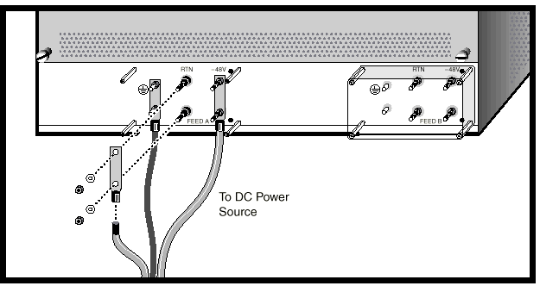
Figure 5 - Power Connection Details

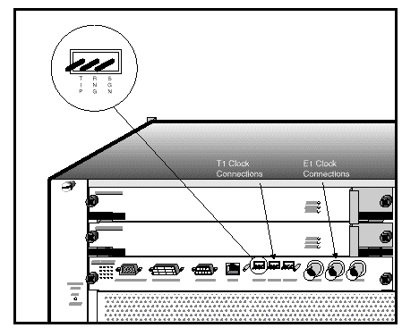
Figure 6 - Timing Connection Details

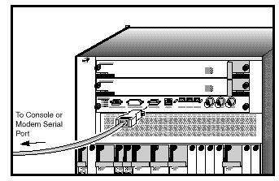
Figure 7 - NMS Connection Details

TO BE PROVIDED

Figure 8 - Stenciling Example for Cabinet Fiber Shelf

NOTE: Slots not marked take OC12 PHY’s.
( 2 fibers per OC48 or OC12; 8 Fibers per OC3).

Figure 9 - Standard Slot Assignments

Figure 10 - Standard Slot Assignments
4. Ordering

4.1 Use BBSWGX550XX MBOS models for the GX550 and associated equipment.

4.2 Order ASND coded equipment from Lucent Internetworking Systems, 3391 Peachtree Road, Suite 105, Atlanta, Ga 30326. Sales contact: Jodie Feldman, ph:404-237-5545, ext. 407, fax:404-237-7972.

4.3 Order ATCS coded components from Atlanta Cable Sales, 5675 Oakbrook Pkwy, Norcross, Ga 30093. Sales contact: Rankin Hailey at 1-800-241-9881 (or 678-775-0208), ext. 231, fax: 678-775-0209.

4.4 E&I vendor may order miscellaneous cables (ACS #07194, #09135, etc.) from Atlanta Cable Sales.

C O M M E N T S H E E T

Your comments will assist us in producing documentation that more accurately reflects your needs:

We thank you for taking the time to respond!

Document Title: RDC Standards for the GX550 ATM Switch, DRAFT

1. How helpful was this document? (Circle one)

1 2 3 4 5
(Not at All) (Extremely So)

2. How timely was this document?

1 2 3 4 5
(Not at All) (Extremely So)

3. How satisfied were you with this document?

1 2 3 4 5
(Not at All) (Extremely So)

4. Please provide any additional comments regarding the quality of this document.

5. Your name and contact No: (optional)

Return to: G. De Lara, RDC, 22A52, BSC, Atlanta, Ga 30375

