 | Support | Cart | Order Status | Add to My Quick Links | Take a Survey

Main View
Part Number: 105553FIC KTBC51G Motherboard
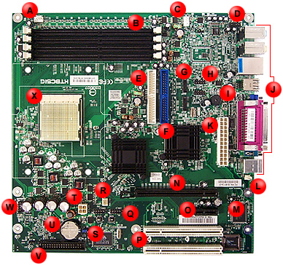 | This is the FIC KTBC51G motherboard. On the graphic or in the table at the bottom of this page, click the hyperlinks for more information.

Item | Description | Item | Description
A | CPU fan connector | M | Chassis intrusion connector
B | Memory slots | N | PCI Express ×16 connector
C | System fan connector | O | PCI Express x1 connector
D | Front audio connector | P | PCI conventional slots
E | Secondary IDE connector | Q | Front Panel IEEE-1394a Connectors
F | Primary IDE connector | R | Power fan connector
G | Serial ATA connectors | S | Clear CMOS jumper
H | USB 2.0 connectors | T | Auxiliary 12V ATX connector
I | Speaker | U | Battery
J | Rear panel ports | V | Floppy disk drive connector
K | Main power connector | W | Front panel connector
L | SIRQ connector | X | CPU socket

