Standard Wiring Pinouts
 | 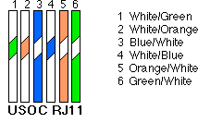 | Standard wiring for an RJ11 or RJ12 connector, Pairs are made from inside out. Pair one is the Blue pair, pair 2 is the Orange pair, Pair 3 is the Green Pair.
 | 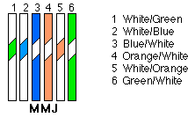 | Also a wiring standard for RJ11/RJ12, Green pair on outside wires, then Blue on pins 2 and 3, orange on 4 and 5.
 | 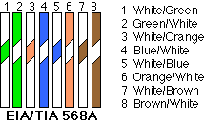 | 568A is used for a lot of ethernet cables. It is one of the two most widely used standards. If you wire both ends of your cable using 568A, you'll have a straight-through cable usable for most ethernet applications. Wiring a cable with 568A on one end and 568B on the other will result in a Cross-over cable for connecting two hubs together, or two computers together.
 | 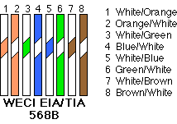 | 568B is the most widely used standard for ethernet cables. If you wire both ends of your cable using 568B, you'll have a straight-through cable usable for most ethernet applications. Wiring a cable with 568A on one end and 568B on the other will result in a Cross-over cable for connecting two hubs together, or two computers together.
 | 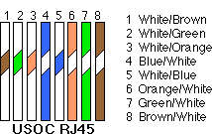 | USOC RJ45 standard is not as widely used, but is an acceptable standard for wiring ethernet. It uses the two center pins for pair one, with subsequent pairs placed to the outsides of each previous pair. Usually used for straight through cables.

